Manual Test Plan

# Setting Up Environment

* Ensure that you have IntelliJ 2019.3 or later installed
* Java SDK 11
* JUnit 4

 

## Getting Code

Download source code from Blackjack folder on Gitlab.

Find all following files:

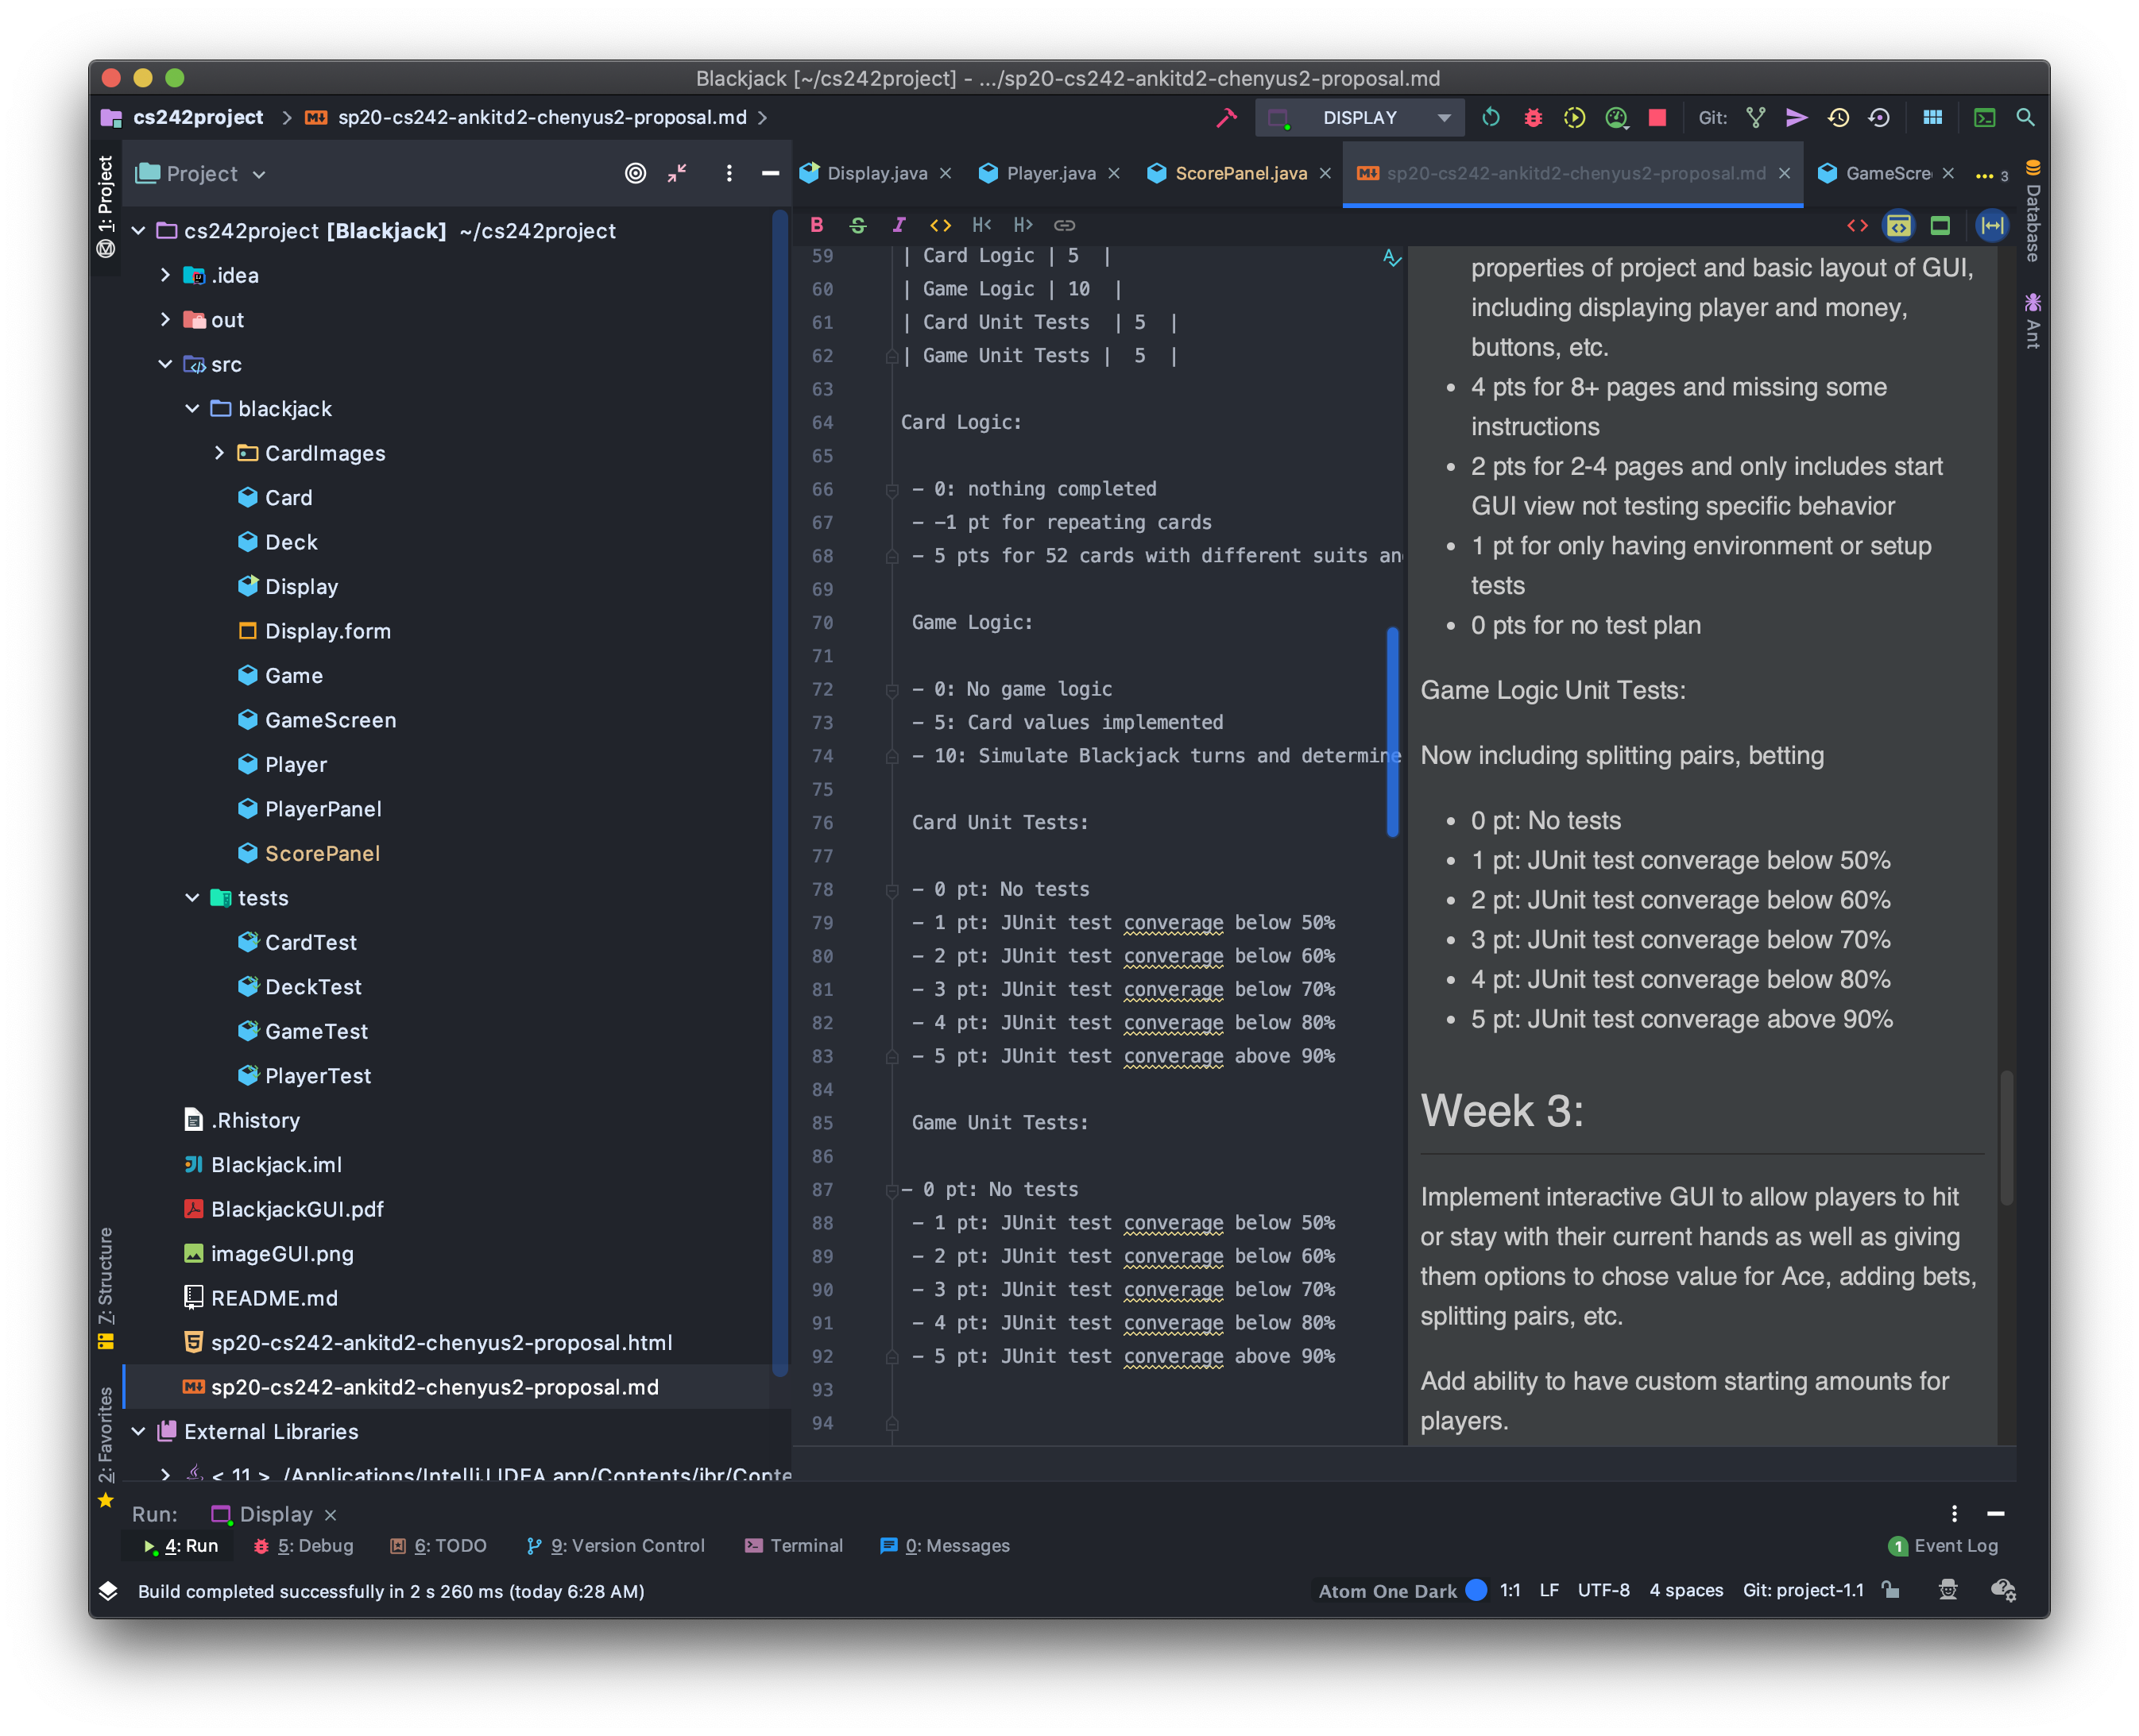

Once the files are verified, you can start verifying the GUI

# Starting Up

In order to set up static GUI with number of players, look for the following line in the code

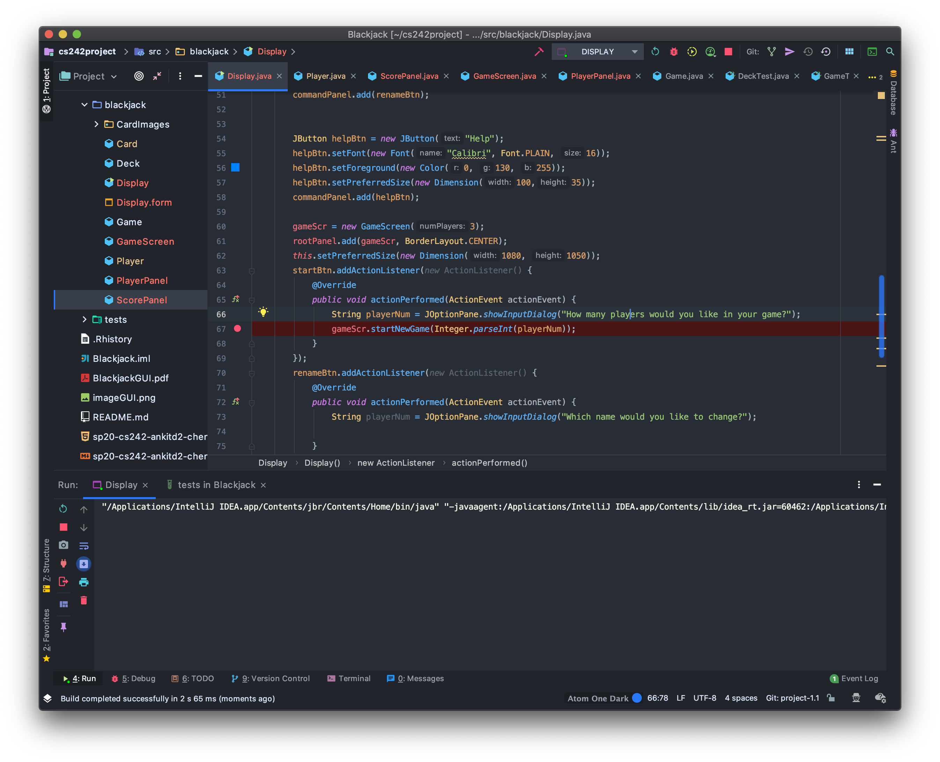

Line 60 Above with gameScr = new GameScreen(numPlayers)

Change the numPlayers to be any number of players that should be shown on initial launch.

1. First open the project folder
2. Open Display Class
3. Click Run

OR

1. Look under pre-existing configurations in IntelliJ
2. Choose Display and click Run

By Default, it is set to 3, so a Blackjack game with 3 Players and a dealer should be shown:

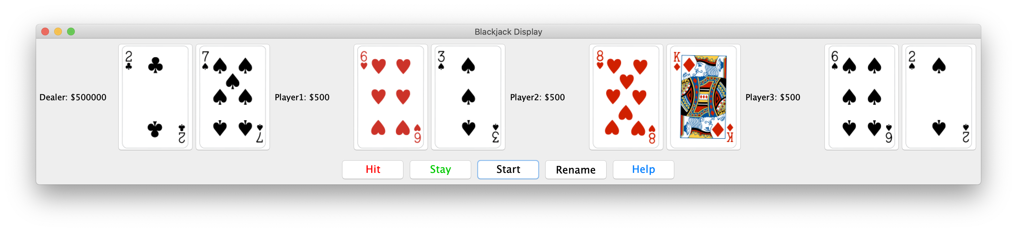

Make sure that there are 4 hands shown with no repeated cards and all unique.

## Changing number of players:

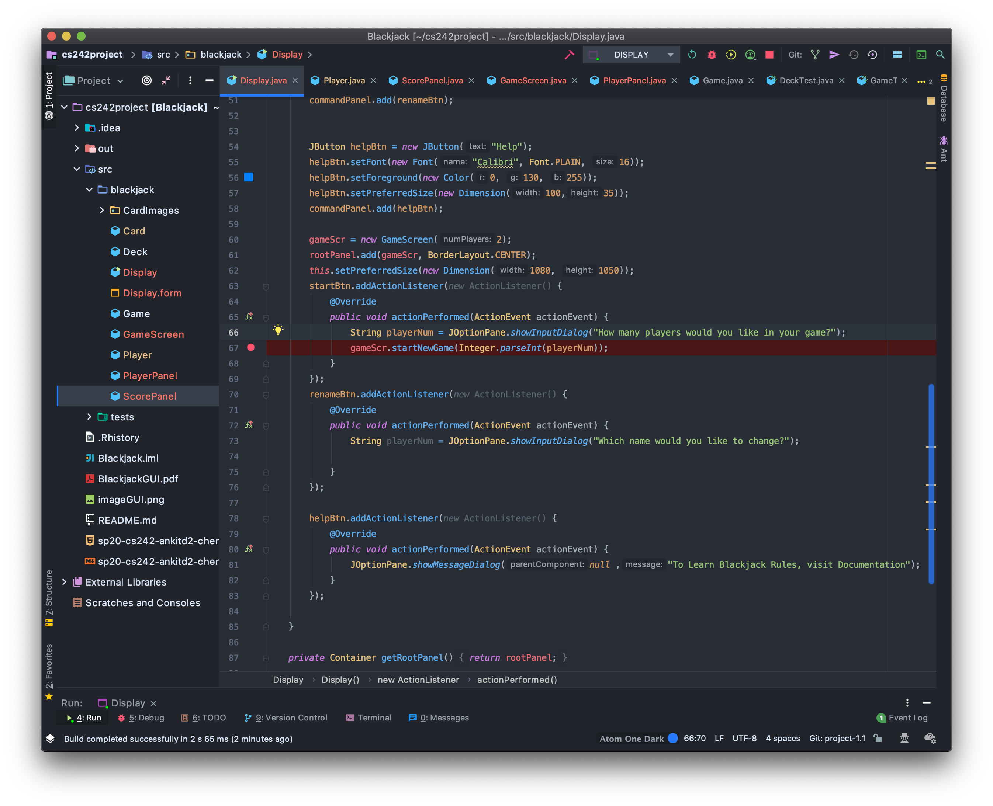

Locate the code again but this time change the constructor on line 60 to have numPlayers = 2 to start a default game with 2 players and a dealer:

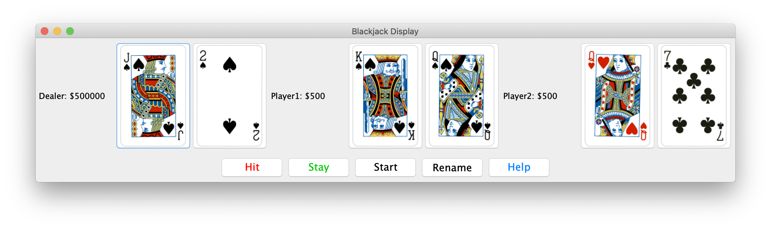

On each startup, make sure:

* Player names are correct
* Dealer name is shown
* All money amounts are shown
* 

# Buttons



By default, the 5 buttons should be shown as above:

* Hit
* Stay
* Start
* Resume
* Help

# Start

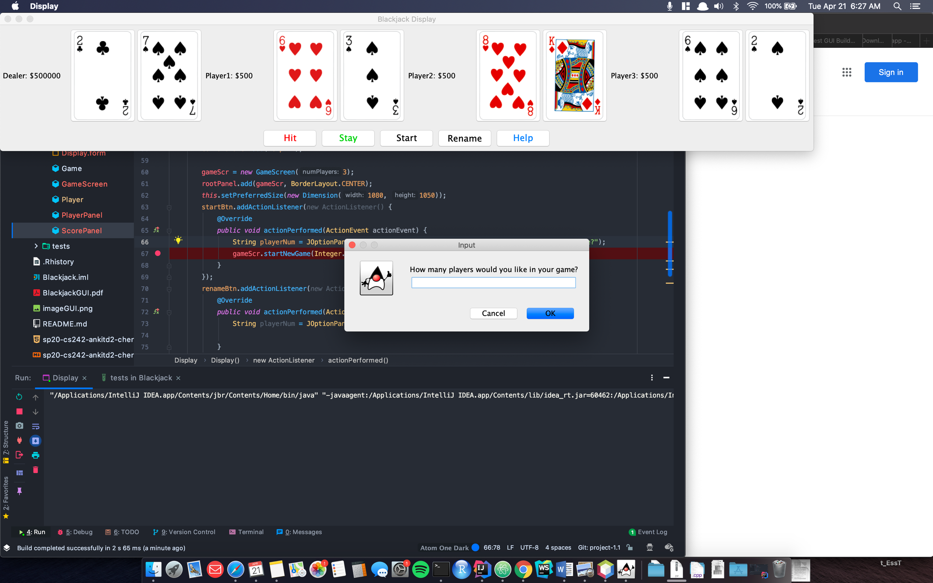



The dialog should allow you to enter how many players you would like there to be in the new game that is to be created.

After entering 2 to create a new game, the new game should appear



# Renaming

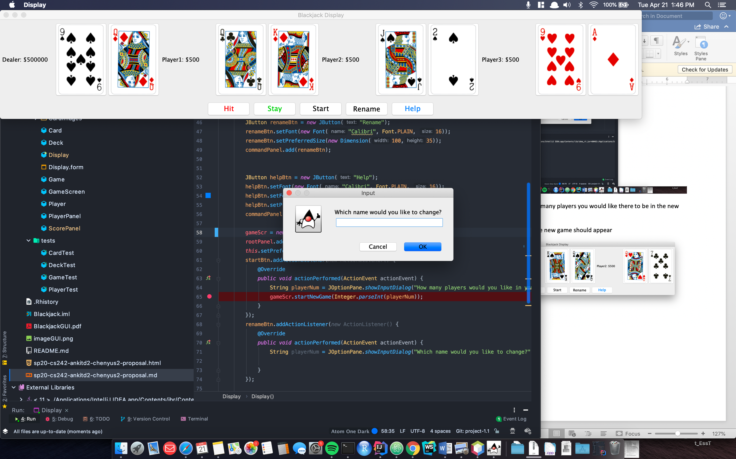

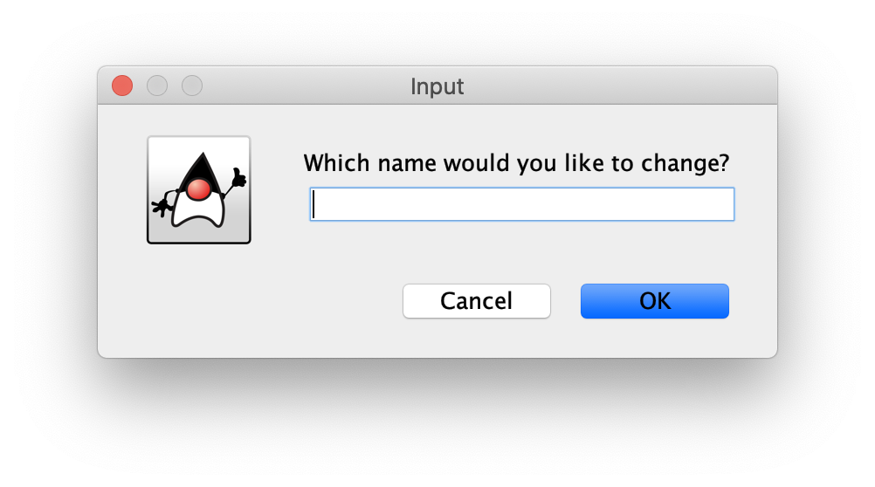

Players can be renamed and their names will be updated if they are found to be a player in the current game

# Help

Explains the Blackjack rules by going through documentation

Docs:

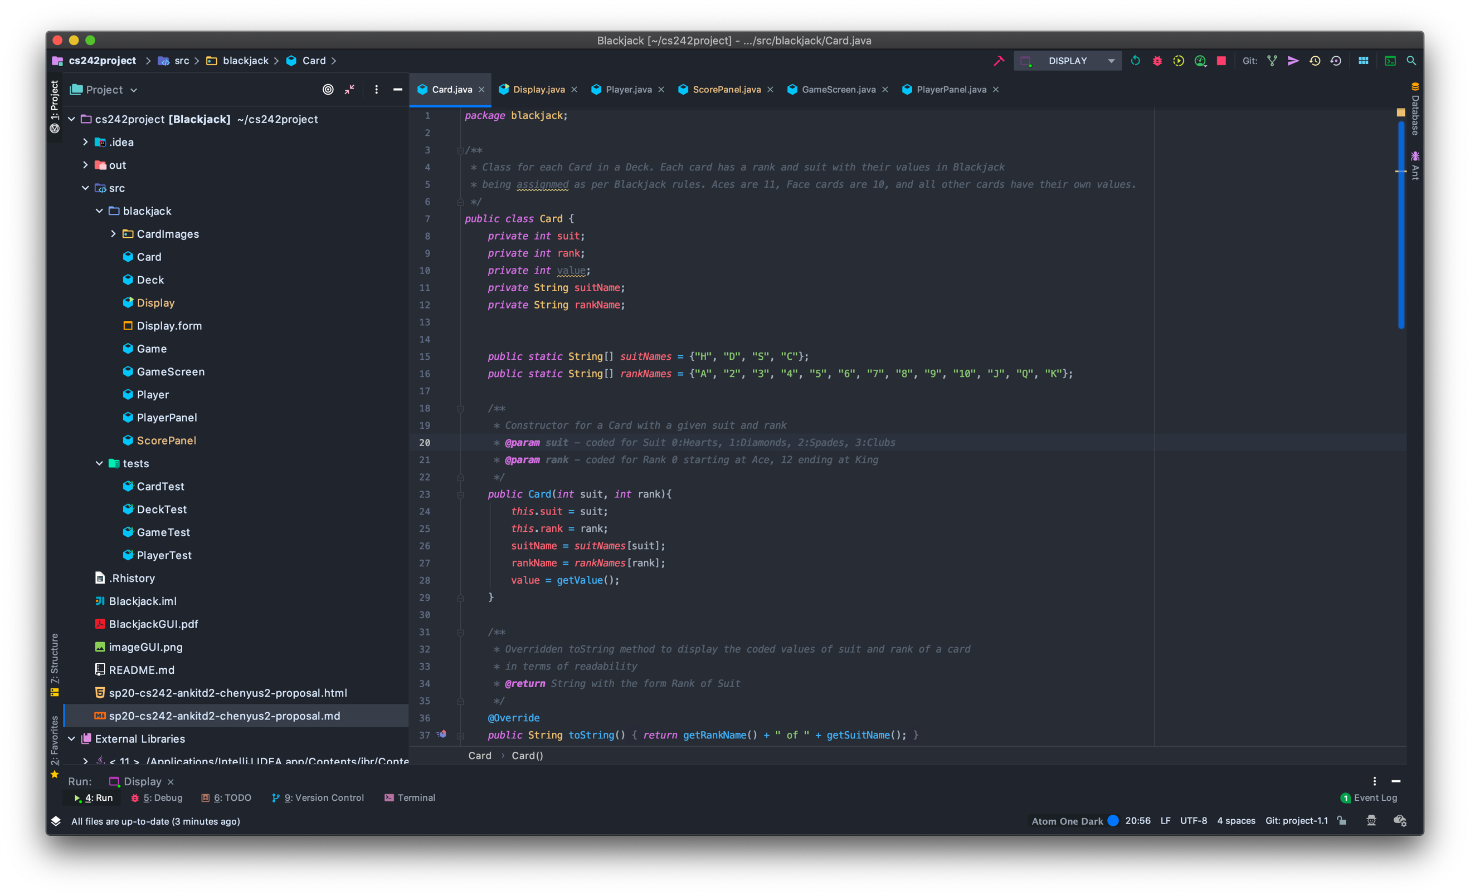

Explains coding of ranks and suits

# Enhanced GUI

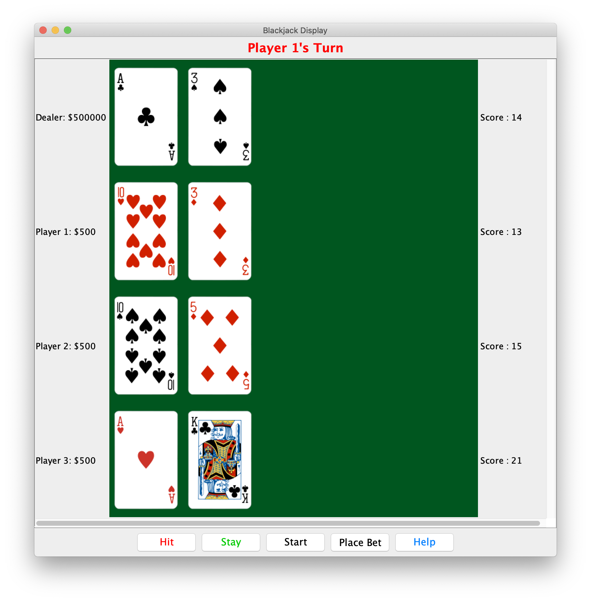

Ensure all the buttons are placed properly and there are 3 players a dealer upon first startup.

All players should have $500 starting budget to make bets

Buttons should read: Hit, Stay, Start, Place Bet, Help

# Placing Bets

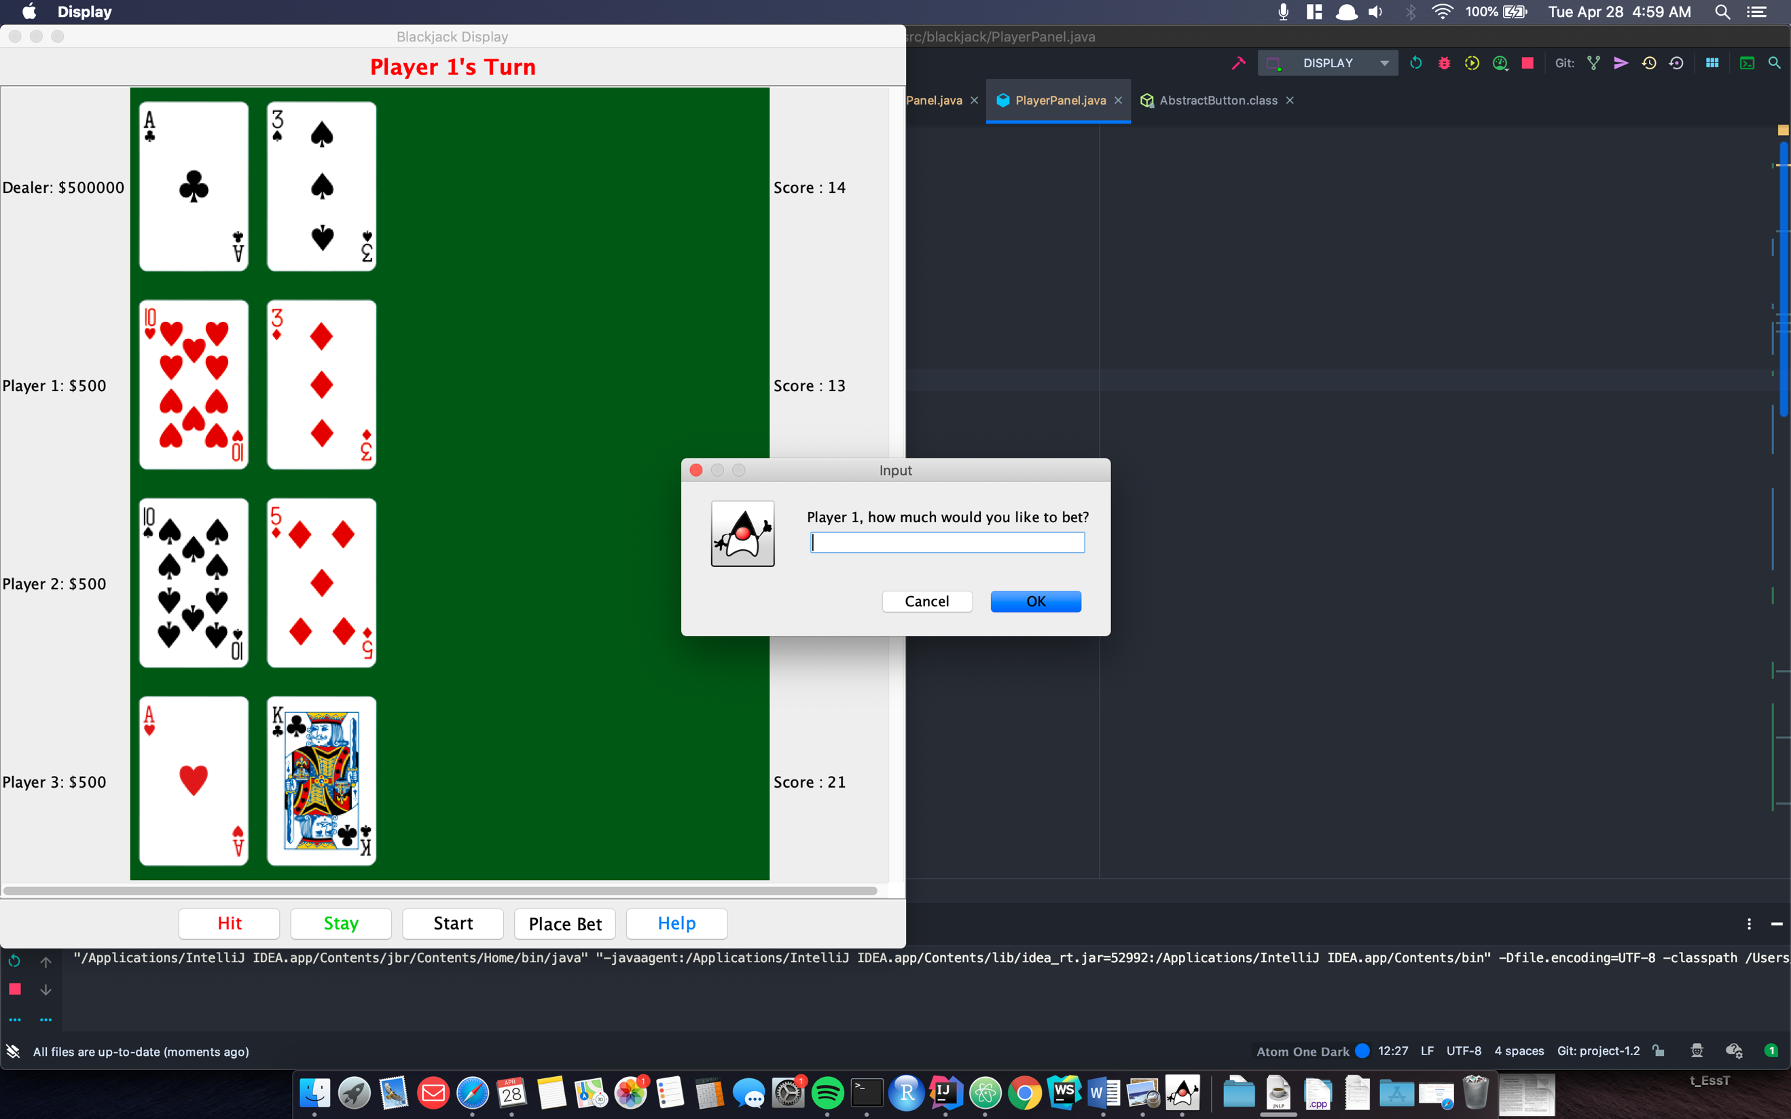

There are 2 ways go place bets:

1. Click on the Place Bet button and a dialog window will appear to ask the player for their bet
2. Click on the Hit button, and if the player has not yet placed a bet, they will be asked to place a bet before receiving their next card

# Hitting a Hand

Click on the Hit button and enter a bet.

Then a card will be dealt from the deck and depending on the player’s current hand, it will be determined if a player will bust or stay in the round. The score calculator on the right side will show the players current hand value.

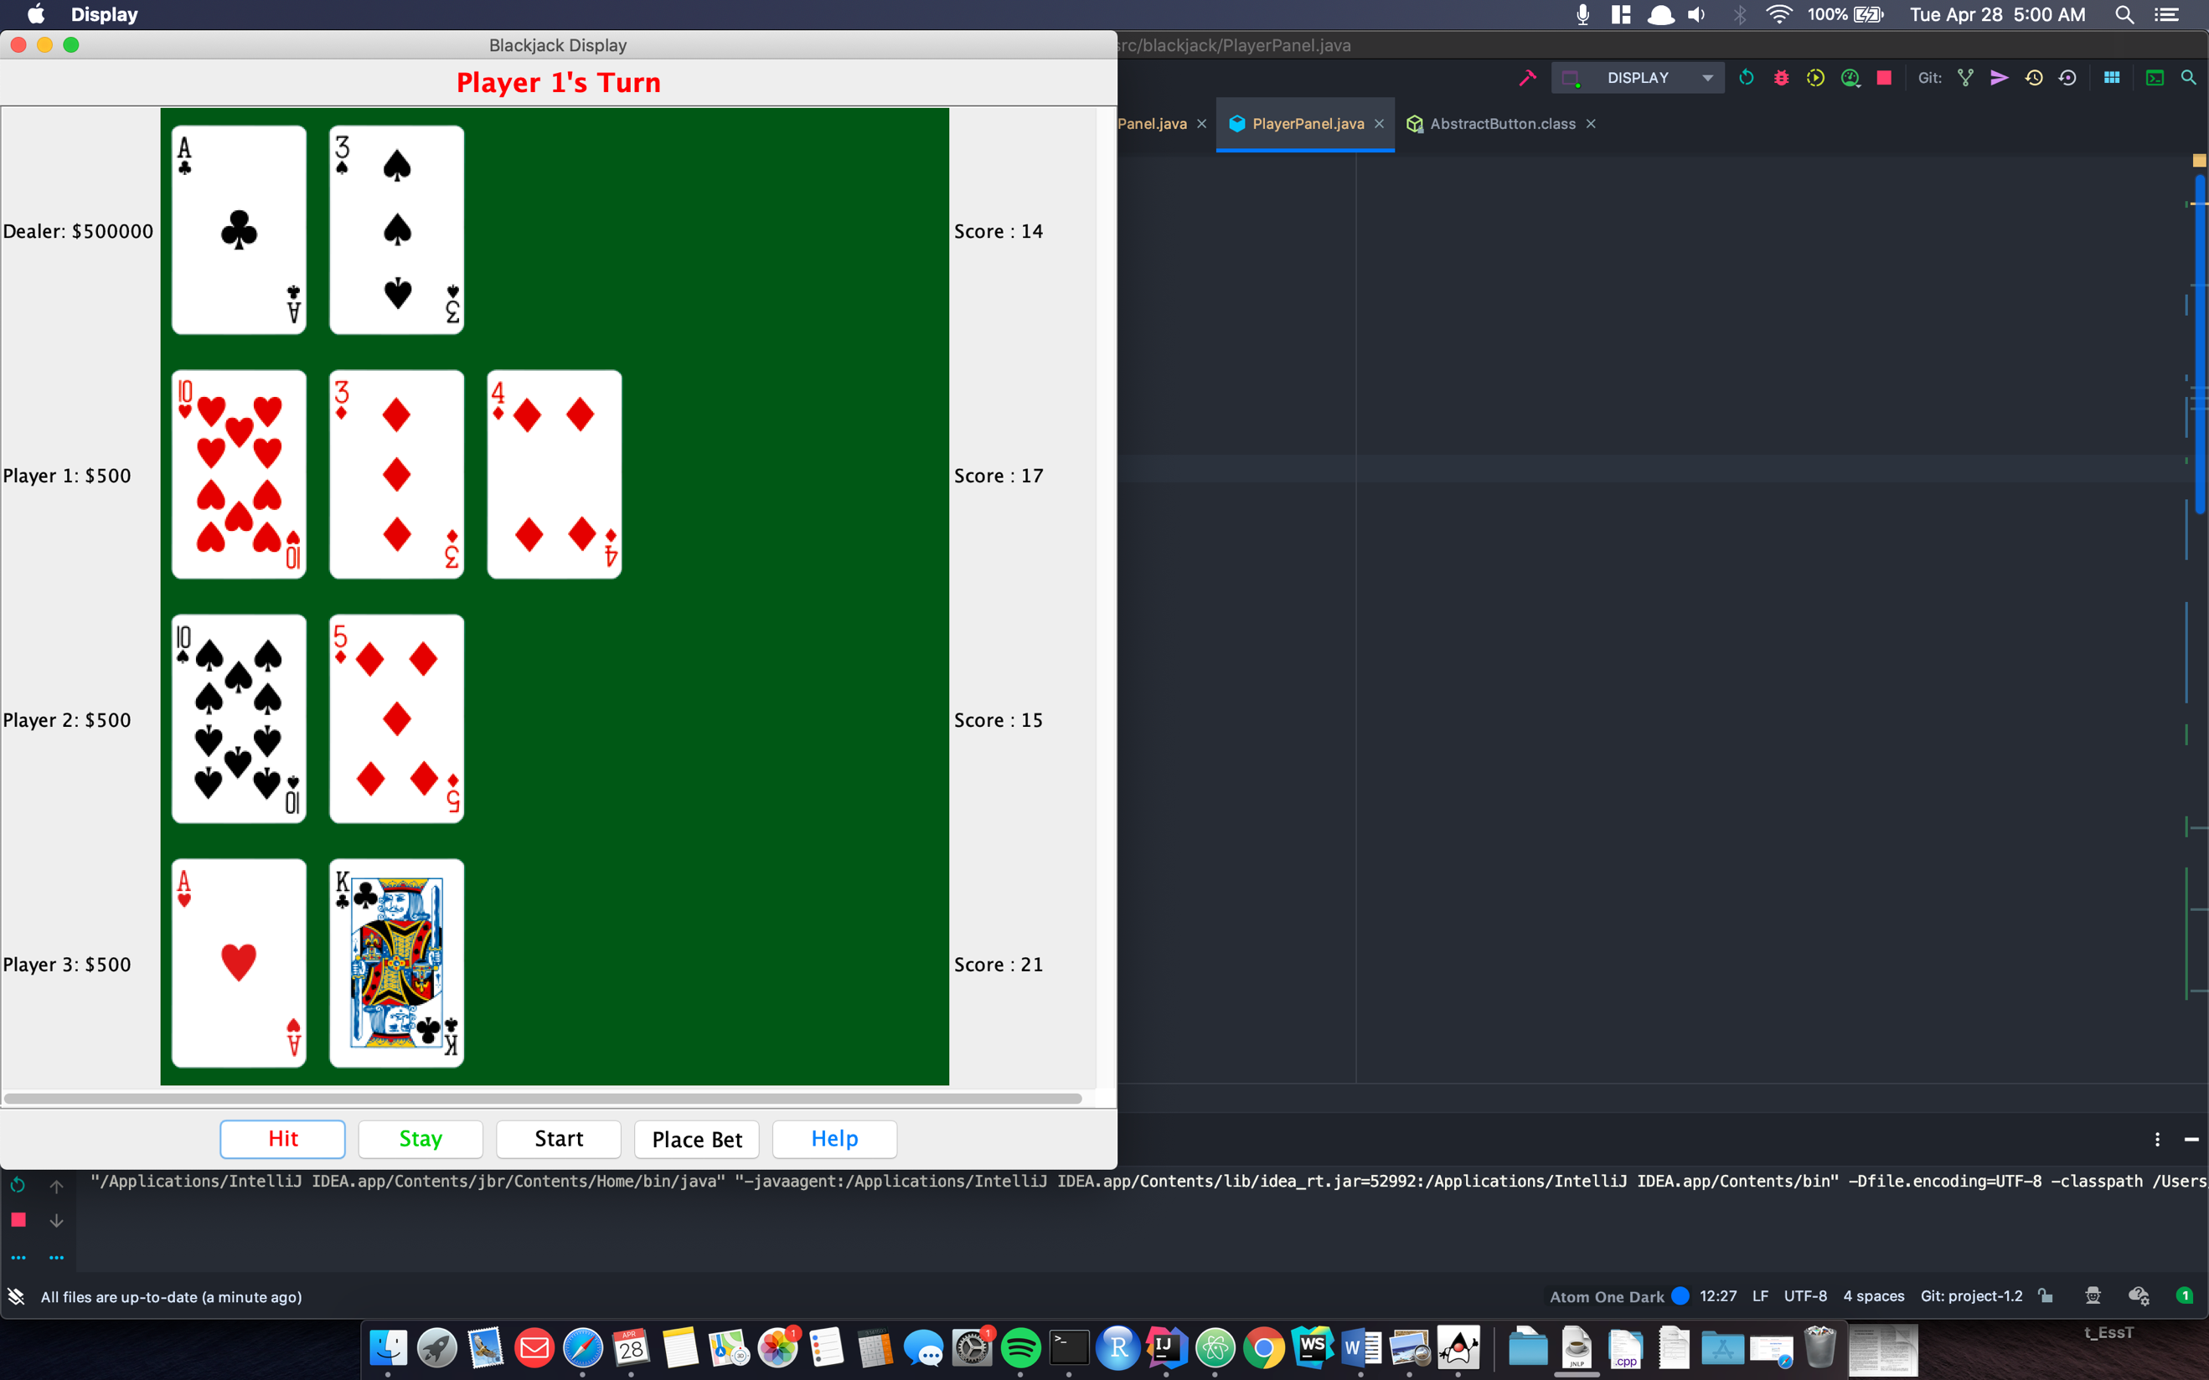

Click Hit again to get another card until there is a bust.

# Busting

# 

After busting, you should see a pop up saying you have bust. After clicking ok, multiple steps should occur:

1. Player 1’s money value should be subtracted by the $100 that was bet
2. The Turn label on the top of the screen should switch to Player 2

# Staying

Instead of hitting a player’s hand, try clicking on the stay button, nothing should be changed for Player 1, but the turn should now change to player 2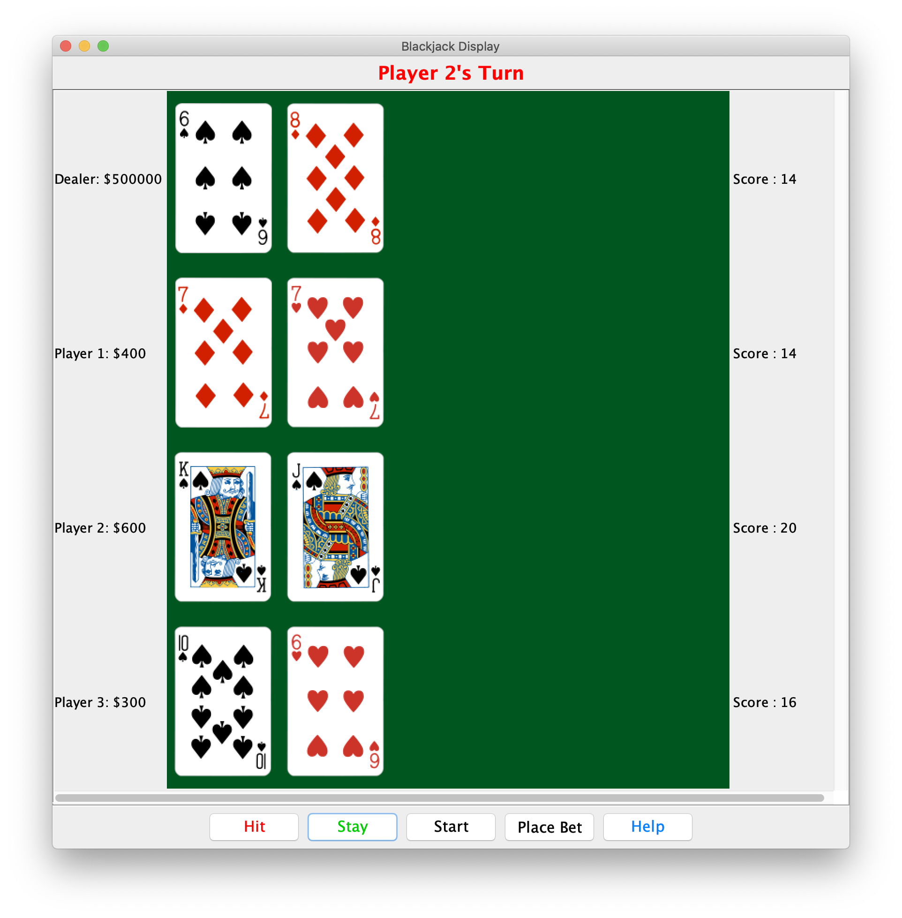

# End Game Conditions

After all the players have chosen to bet, and made decisions about their hand, the round goes back to the dealer and the dealer must keep taking cards until they reach a score between 17-21.

There are many possibilities for how a game ends:

## Dealer Busts

If the dealer Busts, then everyone should win and everyone who hasn’t bust before the dealer will be paid out.

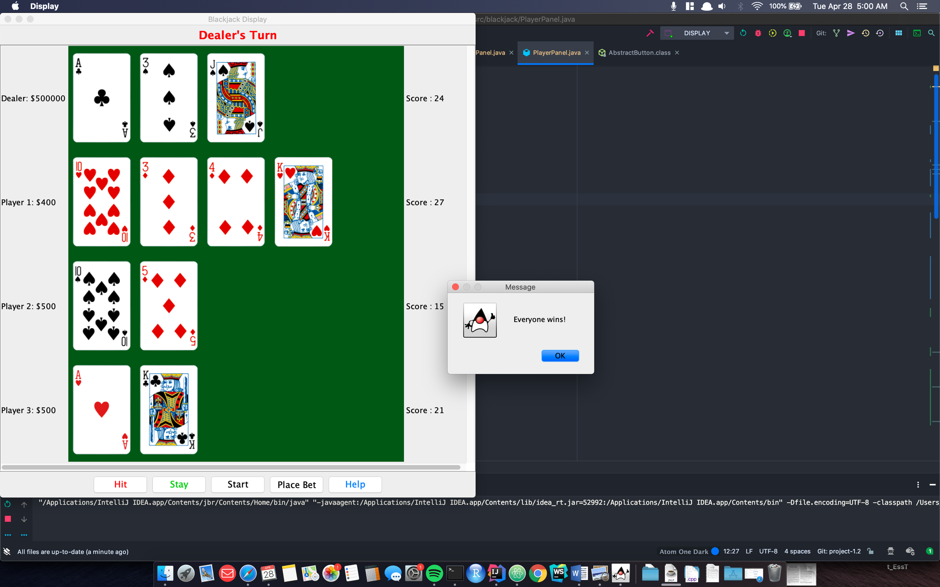

## Dealer Wins

## 

In this case, all the players who are still in the round and have not bust will be paid out their bets, or 0 if they chose not to place any bets.

## Dealer Gets Blackjack

In the event that the dealer gets a blackjack, everyone loses and all their bets are lost

